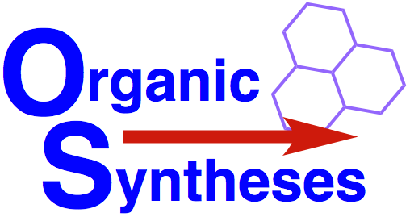 | Characterization Checklist  Please provide the indicated information  for the product of each step in your article  (Any deviation from the Org Syn guidelines with regard to scale and proof of purity must be justified in a cover letter and will only be approved for extraordinary cases)

Corresponding Author _______________________________________

Compound # | Amount of Product  Must be at least 2 g and not more than 50 g | % Purity  Must be at least 97% purity or combustion analysis within 0.4% of calculated | Method Used for Determining Purity  Quantitative NMR, GC, or HPLC vs. internal standard or combustion analysis
Copies of Chromatographs or Q-NMR spectra should be provided.

Signature of Corresponding Author

